Earth Hour 29 Maret 2008

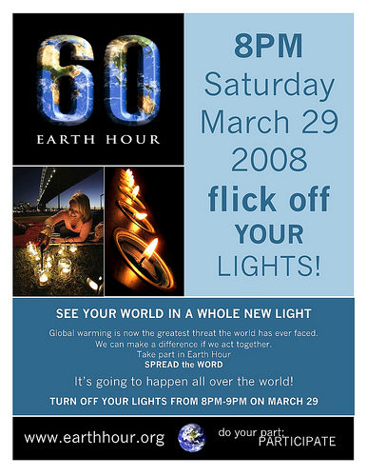

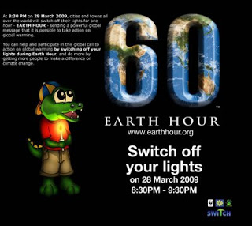Earth Hour 28 Maret 2009

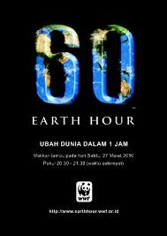Earth Hour 27 Maret 2010

Earth Hour 26 Maret 2011

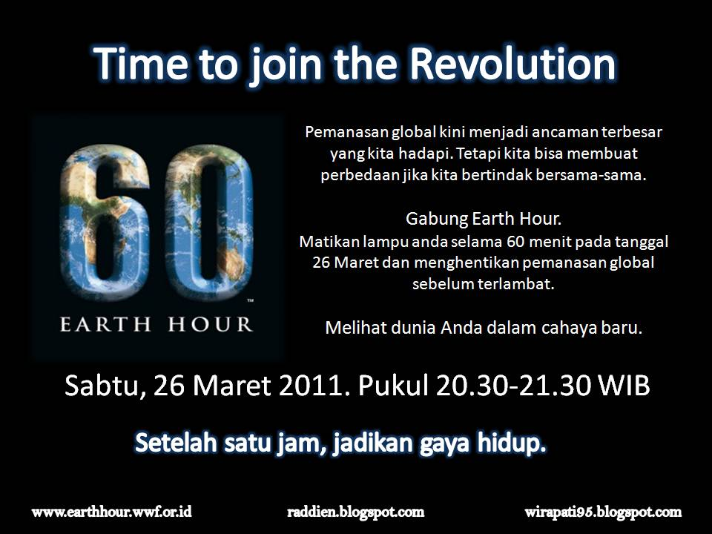

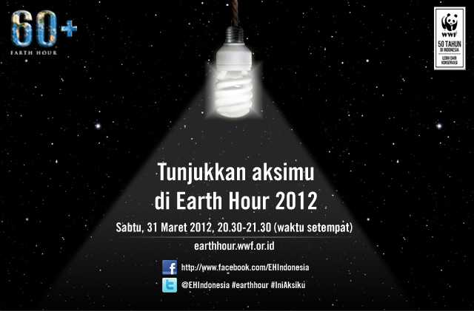Earth Hour 31 Maret 2012

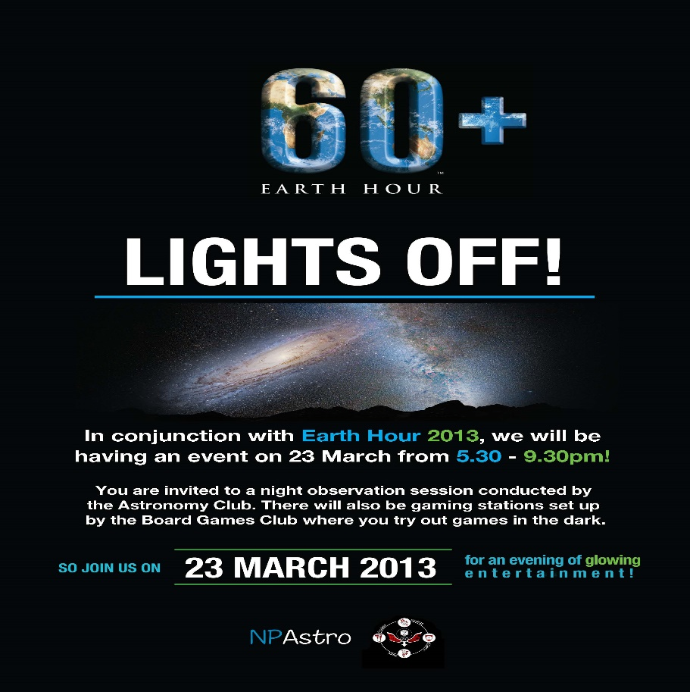Earth Hour 23 Maret 2013

Earth Hour 29 Maret 2014

